Summery of the information about angels on the website
www.rinirikkert.nl (in Dutch, but Google can translate it for you)

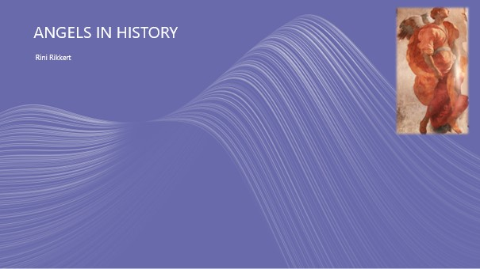

Hi! I am so happy to be able to tell you something about my favorite subject: the angels. I have been studying them for years, in addition to my job as a pastor in the Protestant Church of the Netherlands. For more information – see my website. And for now: I am not a professional translator. You will notice

Let’s start with some history.
In the Bible, angels exist completely without saying — little is explained about them. But how did that idea actually come about, the idea that there are higher beings who care about the fate of people and of this earth?

For that we have to go back to prehistory, the oldest times. From the very beginning, people see life as animated, inspired, and not only themselves, but also nature and the cosmos. And they felt connected, they were able to make contact with the spirits and learn from them. But to get to know a bit more, we have to rely on ancient stories and on what is found in the ground…
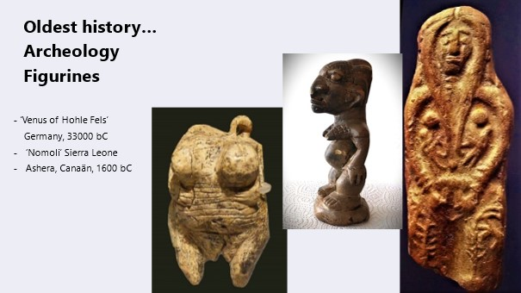

It all started with small figurines. Some 30.000 of them have been found in Europe alone – the oldest can be seen here on the left, it was found in Germany. It is about 35,000 years old. But not only in Europe - such figurines have been found all over the world! For example, you can also see one from Canaan here. I myself have a so called ‘nomoli’ from Sierra Leone, one of the figurines that was buried there on the edge of a field, in order to promote the fertility of the land. People then had no problem imagining those figurines had their own spirit and to keep them close probably helped them to keep the spirit world in mind, and honor them. At their turn the spirits offered people protection, helped to gather enough food, or, being the spirit of an ancestor, could even give wise counsel. The figurines were given a place of honor in the houses, or were worn on the body (see the loop on the oldest figurine). In the Bible (Genesis 31) you will find a trace of this in the story of Rachel who picks up the domestic figurines when she leaves for Canaan with Jacob and Leah.

These figurines are also often found in ancient tombs. There they served another goal, namely to guide the deceased to another reality. That they believed in such a reality can also be seen from the other so-called 'grave gifts'….

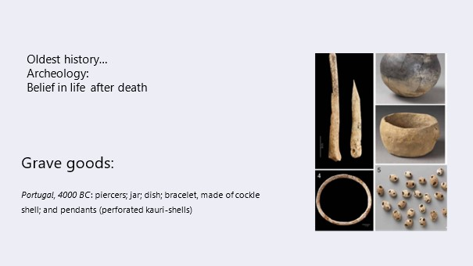
This man or woman, who died 6.000 years ago, got useful grave gifts, such as pots and kauri shells: these shells were a means of payment in ancient times. So the idea must have been that life would go on. Probably in a sort of underworld. But some tribal elders who already had a lot of influence during their lifetime remained connected to their tribe even after their earthly death and their spirit could then, for example, take up residence in such a figurine, but also in trees or in rocks ...

Now, of course, you may wonder how people got thése ideas again! most researchers think it’s all about people's fears and insecurities, (not to mention their need for control) that they made this up - and that will certainly have played a role, but of course it wasn’t all fantasy. There is another more important factor, and that is the experiences they had themselves ...

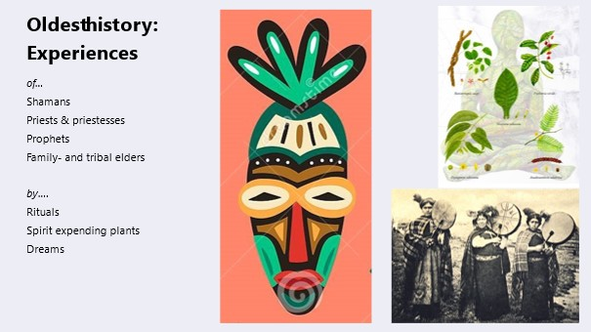

There were always people with a special talent to connect with the other side. For instance, you see here an African mask, which was used in rituals to invite certain spirits of ancestors to connect with the persons behind the mask and thus pass something of his energy on to them. I mention a few titles, such as shamans, priests, prophets – they were professionals, and they were undoubtedly further trained. There were always rituals involved – our church services are still a faint reflection of that.
Then there were the mind-altering drugs: at the top right of the picture you can see the ingredients for ayahuasca, which has been used for centuries in South America to connect people with their deepest selves, with higher reality, with spirits, angels... and their own bodies. There are many methods to get into a higher state of consciousness: I mention music (shamans often use drums), and dances. But also art, think of the cave drawings that were found and also had a spiritual meaning.

From the eighth or ninth century BC we learn to write. From that time on, we have a clearer source of information – the texts.

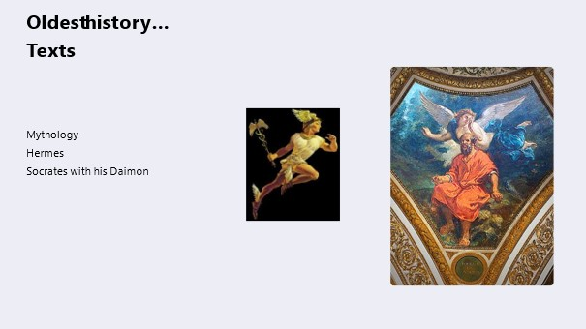

I will limit myself here to the Greeks, because it influenced the western way of thinking the most. In Greek mythology, there is certainly no sign of a helpful kind of angels. Here they have become powerful gods who go their own way. In doing so, they also reflect - as they always do in peoples minds - the society in which these kinds of stories arise: in the Greek city-state it was a small male elite that had the power and who cared little about the common people. There was one mythical exception: Hermes. He was the son of supreme god Zeus and the nymph Maia. Nymphs were earthly nature spirits, and that made Hermes the right person to act as a messenger between heaven and earth – like an angel!

But there is something else reminiscent of the later guardian angel - and then we come to talk about Socrates, the great philosopher. With him we regularly come across a 'Daimoon' – our word ‘demon’ derived from this. But the voice inside that regularly gave him good advice had nothing demonic. The well-known psychiatrist Carl Jung gave the following explanation: The Greek word 'daimoon' expresses a certain power, which comes to man from the outside, although the ethical decision is left to man. However, he needs to know what he decides and what he is doing.' Carl Jung knew what he was talking about. He says in his memoirs that he himself had experiences with such a ‘daimoon’, with which he was first introduced in a dream. He even had a name, ‘Philemon’, and Jung had long conversations with him. Was it his higher self? His guardian angel? Maybe both. It is clear that he would grant such contact to everyone. He writes, ’In the end, most of our difficulties depend on losing touch with our instincts, with the ancient and unforgotten wisdom stored in each of us."

Let's look at the angels in the Bible now. There is clearly a development there too.

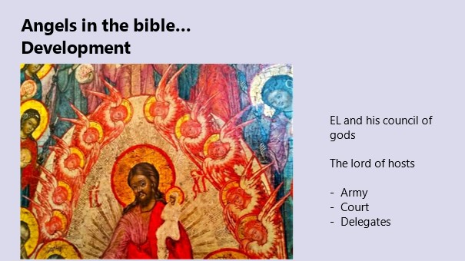

In the oldest stories we see the god El as president of the council of gods. Together they discuss the earthly state and intervene if they find it necessary. That there were countless other gods has long been taken for granted. Only later, when the idea that there is only one God of heaven and earth takes hold in Israel, do the others acquire a lower status of obedient servant, or angel. And just as the earthly kings increasingly dwell in splendor in distant palaces, so too God stays somewhere high in heaven, on a throne, surrounded by his court. You rarely come across that court here on earth, and they have separate names for it. We on earth usually have to make do with the 'angelos', the Greek word for messenger.

In the heavenly court we find the cherub and the seraph…

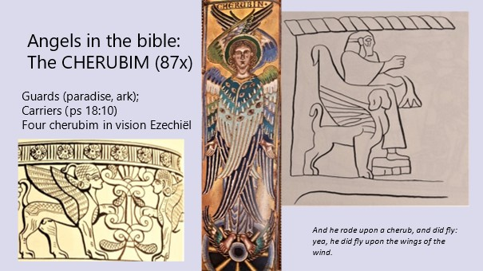

The name 'cherub' can be found about 90 times in the Bible, usually as a description of figures on murals, tapestries or sculptures. The first real performance is in Genesis 3, right after Adam and Eve have been chased out of paradise: ²⁴ And after God chased them away, he placed the cherubs and the flashing sword east of Eden's garden. They had to guard the way to the tree of life.' That flaming sword is especially reminiscent of lightning.(The Canaanitic God Baäl is often depicted with a lightning in his raised hand too). Cherubs often acted as guardians, of the temple for example, or at the ark, or as bearers of the throne of the gods. You needed power figures for that, so he was usually depicted with a lion's body.
With the prophet Ezekiel, the picture changes: he sees in a vision the cherubs right under the throne of God in heaven, in a fire of lightning bolts. For him they have four faces, of a lion, a bull, an eagle and a human. And wings. That was also a special feature of those court angels: they had wings, the angel-messengers had not.
Ezekiel also describes spinning wheels, covered with eyes: they were later given their own name, the 'ofanim'.

A word about the symbolism of the images: a quote from a well known Dutch Reformed theologian Abraham Kuyper, who dared, around 1900, contrary to the spirit of the times, to write a thick book about angels:
"You cannot derive from the visions the right to conclude that cherubs as such winged physical beings also exist in the same way. You can compare it to an image of justice as a blindfolded apparition with the sword in hand, or if we imagine time as an old man with scythe and hourglass. Justice and time are in themselves imperceptible, and must therefore derive a representation from our human imagination. And it is the same in the Bible. Wherever the vision occurs, everything takes shape and form, so that it might thus address us through and in that form.'

On the picture you see a God or a king on a throne carried and protected by two cherubs. The middle cherub is painted after the description of Ezekiel: in a later vision he also saw eyes on the body of the cherubs. They could see everything! On the left there is a part of a band with cherubs who guard the tree of life. The tree was also an important symbol of the Canaanite goddess Asherah (maybe you heard of the numerous times the kings of Israël cut down the trees of Asherah on the hilltops…)

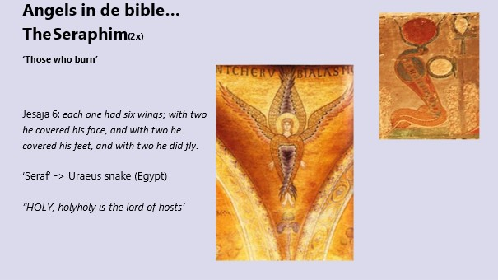

About the Seraph. He is mentioned only twice, again in a vision, this time of the prophet Isaiah. The seraphim do not move under, but above the throne of God. This is how they looked like: "Each of them had six wings, two to cover the face and two to cover the lower body, and two to fly with."

He does not say whether they are human figures. Not so likely, because the Hebrew word "srf" can also mean "snake". Seals have been found in Judah from the eighth century BCE, depicting an originally Egyptian uraeus serpent. That stylized cobra serpent was a protector of man on behalf of the gods, you could often see it on the foreheads of Egyptian kings and queens and in temples on the walls. She offered protection through her 'fire' or poison.

According to the prophet Isaiah, in his vision they are mainly concerned with praises. A sound, so loud that 'the door pins shake in the sills'.... And then it also radiates a fiery heat. Isaiah feels very small, guilty, and scared now. But then a seraph comes flying towards him, grabs a glowing coal from the altar with pliers and touches his mouth with it. 'Now your lips are cleansed' he says, 'your guilt is gone, your sins are nullified'... .
Fortunately, it is a vision, not a concrete glowing coal, and its symbolism is very beautiful: The heavenly fire has burned away all earthly barriers, Isaiah is ready to speak directly to God. The angel paved the way.

The next category probably sounds a bit more familiar to us: the archangels. 'Arch' has nothing to do with ‘earth’, it comes from the Greek word 'arch' which means 'highest'. They are the most important representatives of God on this earth. In our Bible only two are mentioned by name, the third in the apocryphal book of Tobit. (Apocryphal books are written in the same time-period as the other bible-books, but they did not end up in the official canon). In other ancient literature there are many more angel-names, almost all of which end in 'El': God.

One exception, which later came to play an important role in Jewish literature: the angel Metatron, once started as the biblical man Enoch. From man to angel – that was not the custom. Enoch was an exception, because according to the biblical story, he did not simply die, but was taken up into heaven. Because of this special position, he is also called the 'angel of humanity'.

But let’s find out more about the archangels now.

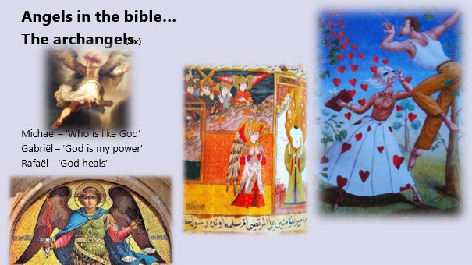

The angel Gabriel first appears in the book of Daniel in the Old Testament (written around 165 BC, so rather late) He explains the visions to Daniel and although he looks like a man, Daniel is so frightened that he falls upside down when he sees him first. In the New Testament, he appears to Joseph in a dream, and appears to Mary to announce the birth of Jesus. (I couldn't resist showing you this great modern picture of that). Gabriel explains, announces, and goes to war. He is at the head of all powers, a role he sometimes shares with Michael, and he sits on the left side right next to God - again with Michael on the other side.

Gabriel, alias Djibril, has an important role in the Qur'an, where he is called "the believing spirit," as the constant counselor and companion of the Prophet Muhammad. It is Djibril who passes on the revelations to the prophet. He usually appears as a very strong man, dressed in two green garments and a silk turban, but it is said that in its true form he is gigantic, and has 600 wings, each pair of which fills the space from east to west. The other biblical archangel, Michael, is also mentioned in the Qur'an, and is called Mikal there.

Michael is the protector of Israel in the Bible. He enjoyed the most fame, and was therefore connected to just about all stories in which there is talk of an angel without a name. He is sometimes referred to as "the prince of the army" or "the commander of the Army of the Eternal" or simply "commander of the angels." In this way, he increasingly becomes the angel who confronts evil. In the end of times, he is the one who defeats the "dragon." Michael also acts as an intermediary between God and the guardian angels. Or he receives the prayers of the faithful, or is called the key keeper of the highest heaven. As the number one of the adoring angels, he is later assigned in a kind of priestly role. There is also a tradition in which Michael, as a companion of souls, is responsible for caring for the deceased.

Archangel Rafael first appears in the apocryphal book of Tobit. In chapter 12:11-15, he introduces himself, "When you, Tobit, prayed, and when Sarah prayed, it was I who brought your prayers before the throne of the Lord. When you buried the dead, so did I. And when you left your meal without hesitation to bury that dead person, I was sent to you to put you to the test. But God also sent me to deliver you and your daughter-in-law Sarah. I am Raphael, one of the seven angels who are in the vicinity of the Lord's throne." You notice the number of archangels can differ. Three or four or seven or twelve… Rafael knows all about healing, even when it comes to defusing demons. For example, he is described elsewhere as the one who heals the earth. He is helpful with all illness and all injuries of human children.

Finally, the angel Uriel 'Fire – or Light – of God' is also often counted among the archangels. There is a clear astrological connection: he is the ''guide of the heavenly lights''. The (fallen) angels are often also seen as stars, so Uriel also participates in the apocalyptic battle. He will one day break open the gates of the underworld, and show the dead the way. Later, he is mainly the angel who reveals secrets, and in this way he is the big favorite in magical texts.

The picture shows Muhammad and Gibril in the middle, and left on top Rafaël leaving Tobit, painted by Rembrandt. Michael, below, has here the same sort of lightning-sword, and scales to weight the dead.

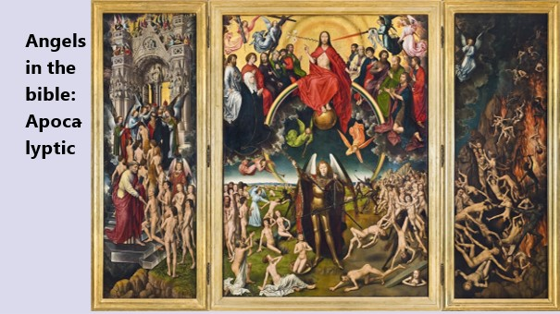

The word "apocalyptic" was mentioned for a moment — it's almost unavoidable when you're talking about biblical angels. They appear more than 300 times in the Bible, which is a lot, but the last Bible book of Revelations takes the cake. No less than 77 times! It is a book about the end times, the visions of John. A popular theme in ancient Jewish and Christian literature, for some 400 years – from 200 BC to 200 AD. And everywhere the angels play an important role in helping to carry out the impending judgment. All very exciting, but I won't go into it in detail. For terrifying scenarios, all we have to do is watch TV for an evening – so for now, I'll skip the fallen angels, devils, demons and evil spirits. It is, in my opinion, much more important to focus our attention on the side of the Light, love and connection. So now I would like to talk about the qualities that are attributed to the angels here and there in the Bible. I've made a list of them...

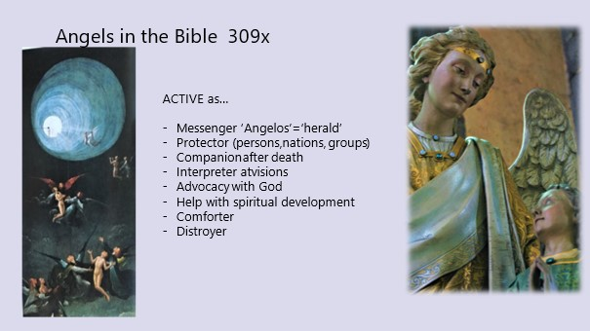

Angels are active in the Bible as...
- Messengers – there are PLENTY stories in the bible about that. I myself like the story in Judges 13 about Samson’s annunciation the most.

- As a special protector angels are not only connected to persons, but also to groups and nations.

- Companion after death – you can find an example of this in Luke 16, in the story of Lazarus. It says...
²² One day the beggar died, and he was carried away by the angels to rest on Abraham's heart.

- They also serve as interpreters for visions, explaining to the prophet what is meant by all those images — Zechariah 1:9, during a vision, "What does that mean, my lord?" I asked, and the angel who spoke to me replied, "I will show you what this means."

- And as an Intercession with God: they sometimes put in a good word for us, a role that we later mainly know from Mary.
Zechariah 1:12: Then the angel of the Eternal cried out, "Lord of the heavenly powers, how long will it be before you show mercy to Jerusalem and the cities of Judah, on which you have been angry for seventy years now?" To this the Eternal answered the angel who spoke to me with words of comfort and encouragement...

- Angels also actively offer Help when people decide to develop further spiritually.
Hebrews 1:¹⁴ Are they (the angels) not all serving spirits, sent to assist those who will partake of salvation?
Acts 7 ⁵³ you who received the law through the intercession of the angels, but did not live by it."

- They offer Comfort in difficult times...
Mark 1:12-13 Immediately afterwards the Spirit drove him into the wilderness. For forty days he remained in the wilderness, where he was tested by Satan. He lived there among the wild beasts, and angels took care of him.

- And after all those positive activities, we now arrive at the Destroyer – Well. The destructive angel is a recurring phenomenon in the Bible… A whole Assyrian army, the firstborn of the Egyptians, punitive measures during the journey through the desert... Angels are certainly not always sweet and kind. Or never, really. They are far too grand and powerful for that. It seems to me that we are still dealing here with a remnant of the old war gods, who, although now turned into angels, are still just as bloodthirsty in people’s minds. As I said – I'll skip them for this lecture.
Acts 12:21-23 On the appointed day, Herod sat on his throne in his royal robe and addressed the people. People shouted loudly, "Here speaks a god, not a man!" Immediately Herod was felled by an ANGEL of the Eternal for not paying homage to God, and eaten by worms he breathed his last.
2 Samuel 24:16 But when the angel extended his hand to Jerusalem to sow death and destruction there as well, the Eternal began to lament the mischief that had been done. 'Enough!' he said to the angel'...

What further descriptions are given in the Bible of the angels…

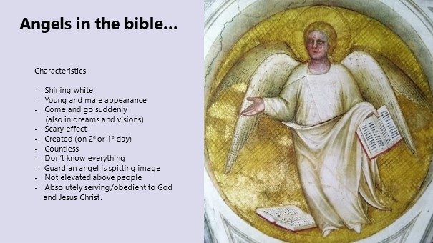

- They are Shining white – everything that has to do with heaven is always associated with Light... In the oldest stories it is more often simply ‘a man’.
Luke 2: message ad shepherds) "and they (the shepherds) were surrounded by the radiant light of God"

- They always have a Young and masculine appearance - that had to indicate something of strength, and flowering. Of course in biblical times nobody came up with the idea of a female angel, or of a gray old man... or a child… It was only much later that the strong lion-like Cherub changed in art into a chubby baby figure…

- They appear and disappear suddenly... In principle, angels remain invisible to earthly eyes, but they were able to take on human form in special cases. Next to that, there are also many stories in which they appear in dreams and visions.

- Their appearance creates a Scary effect – Daniel fell upside down, but very often people are shocked when they suddenly have to deal with such an appearance: the first words of an angel are often "do not be afraid"... no idea if that helped.

- Are angels born like humans, or not? The Bible makes no statement about this, but in the apocryphal books it is explicitly claimed that angels were also created by God. Sometimes already on the first, or else on the 2nd day. This is important, because it puts them on the same level as people. In the Apocryphal book of Jubilee there is a beautiful poetic description of this event:
- "Write down all history, how God accomplished all his creation in six days and that on the seventh day He kept Sabbath, which he sanctified for eternity and made as a sign for his entire work. Write that on the first day he created the heavens that are above them and the earth, the waters and all the spirits that serve Him: the 'angeli faciei’ the angels of sanctification, the angels of the spirit of the clouds and darkness, of the hail and the snow and the frost; the angels of the voices, of thunder and lightning, the angels of the spirit of frost and cold, of the great heat, of the rainy seasons, of spring, summer and autumn, and the angels of all spirits united in heaven and who are on earth and in all abysses, in darkness, in the light, in the dawn and in the evening. He created them all with the wisdom of his heart.

- How many angels are there – only God knows. Thousand times thousands, says the Bible, in other words, countless.
Revelations 5 ¹¹ Then I heard the sound of a large number of angels around the throne, the beings and the elders; there were infinitely many, ten thousand times tens of thousands, a thousand times thousands.

- Anyone who thinks that once you are in heaven you will know everything, they are probably wrong. Even angels don't know everything, although they know a lot more than we do.
Mark 13:³² No one knows when that day or moment will come, not the angels in heaven and not the Son, only the Father.

- A guardian angel is not really mentioned in the bible, but there are two indications. The New Testament gives rise to the idea that an angel can be assigned to one person. We happen to find the thought in Acts 12, where the apostle Peter escapes from prison – also with the help of an angel, by the way – and is not immediately let into the house where the disciples are sitting together: the maid was startled when she opened the door, and rushed back to the disciples to tell them that there is a man at the door who looks like Peter – but he’s in prison right?! And they say: it will be his angel – apparently it is assumed that such a guardian angel also looks like you. Very interesting of course. Can this be an early form of our idea of a higher self?

- An angel does not feel elevated above people – that was noticeable, in those hierarchical times. In Revelation 19:10 it says, I, John, threw me down at his feet to worship him, but the angel said, "Do not do that! I am a servant like you and like your brothers and sisters who testify of Jesus. You must worship God.' This same text was later misused to prohibit people from any contact with angels – but we'll get to that later.

As a final trait, there is something here that people, apparently unlike angels, always struggle with. Angels, it is said, serve God, and later Jesus, with all they do, and in strict obedience. (1 Peter 3)

Although angels are so important in the bible, in most churches they are completely out of sight these days. HOW COME?? I tried to figure that out, at least a bit, and as a Dutch protestant I expected the great men Luther and Calvin to have had a hand in this, because things were different in the old catholic church…

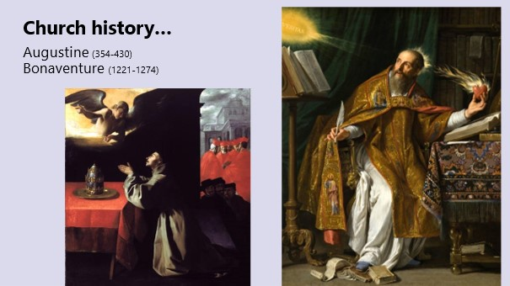

So let’s make a small trip to church history, if only for these two romantic pictures of the church fathers Augustine (354-430) and Bonaventura (1221-1274). Certainly until the end of the Middle Ages, every prominent theologian also wrote about angels. They did their best to make it a coherent story, explaining who angels were, what they did, and how to deal with them. I'll give a few quotes, to show how the ideas developed:

First Augustine: "Angels have a luminous and ethereal body.
It is possible for them to change their bodies to the form they want and which is in accordance with the task to be fulfilled by them.
According to Augustine
- they wrap themselves in a body, just as we put on a garment.
- There is a clear distinction between "spiritual" and "material" matter.
- Spiritual matter (of which the angels are composed) corresponds to that of the human soul. That is also where the connection is, and the possibility of contact.
- The angels pass on the Divine ideas to the lower creatures, in order to form and control them. (Here the hierarchical structure of his own society got hold of him I think)
- They can help the human spirit to receive the light of God.
- The angels are obliged by the commandment of charity to assist the people. Conversely, man is also called to honor and love the angels.
So much for Augustine, who lived around 400. Another theologian, Bonaventura, lived some 800 years later. He says:
Angels have a spiritual substance but can also take a firmer form, if they wish, in order to be seen and talked to by people. But most of the time, angels make contact by giving us thoughts, by our intuition, and through the imagination.
Between these two churchfathers, sometime in the sixth century, there lived an interesting mysterious writer, who would determine the thinking about angels for ten centuries. He called himself Dionysius the Areopagite, after a figure named in the Bible, so his writing gained an almost biblical authority. It took ages before one began to doubt this name, and since then they name him ‘pseudo-Dionysius’… But it’s still a wonderful book he wrote.

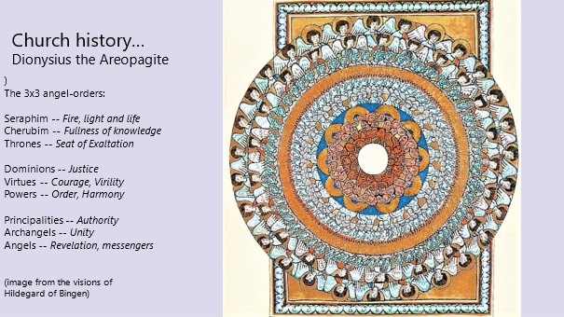
According to Dionysius, we all share in the original, uncreated Light (or what we call God). The entire universe forms, as it were, a cascading waterfall of light, each staircase ('hierarchy') is formed by angels, in three distinct ranks. Every creature, starting with the highest angels, is a recipient of divine enlightenment and transmits it to the best of his ability. Thus, there is always and everywhere a continuous movement of giving and receiving. However it is true that the Light decreases more and more in power and brilliance, as it moves further away from the Highest Light. We are at the end of that chain here on earth, even if it works down to the smallest worm – but the good news is that you can work together to absorb more light and pass it on to others.
Until the Reformation, the angels played a major role in the church and in popular belief. Here, too, they often replaced the ancient local gods and goddesses, and people simply changed the name of an ancient sanctuary, happily continuing what they had always done: reaching out and connect, in their own way.

Until the Reformation, that is. With the growing influence of the Protestant churches, the angels disappeared more and more from view.

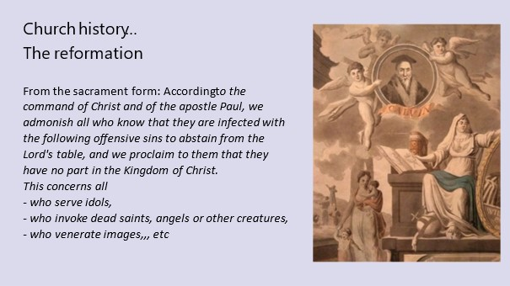

For a start - what do you think of this picture, found in the museum of Dordrecht, of Calvin surrounded by chubby angels? That the angels disappeared wasn't even so much down to Luther or Calvin – F.i. Luther told children to say thanks to their guardian angel every day and gave a sermon at least once a year about them. No, something else came up, and that started with the sacrament. There was a lot of struggle over this, the differences between the lord's supper and the eucharist were greatly exaggerated and a strict new protestant text was written the ‘sacrament form’. This had to be read out loud in every church, every time the lord's supper was celebrated. That went on for centuries. Read the text: if you dared to engage with angels, you were a lost human being. Not that the Bible says anything like that, but as a strict Protestant you had better err on the side of caution.
According to the command of Christ and of the apostle Paul, therefore, we admonish all who know that they are infected with the following offensive sins to abstain from the Lord's table, and we proclaim to them that they have no part in the Kingdom of Christ.
This concerns all
- who serve idols,
- who invoke dead saints, angels or other creatures,
- who venerate images, etc... Further on comes the murderers and thieves and other criminals. All those good churchgoers then left it out of their minds to still be concerned with angels. From now on, everything revolved around 'the word', the Bible, and about God and Jesus.

And on top of that (and of course, next to all sorts of other changes in society), there was something else....

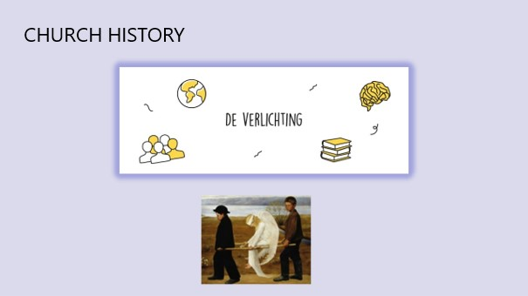

That which later came to be called 'the enlightenment'. Reality is limited to what is visible and tangible. Scientific research shows that the Bible cannot be taken literally.
More and more people no longer believe in a God, nor in an afterlife , and certainly not in angels.
Orthodox, Catholic and evangelical circles do not go along with this in their official teachings, but even there angels hardly get any attention. With one exception… Christmas. As an important player in the Christmas-play for children. That brings us to the ‘NOW”… are angels all gone, or what?!

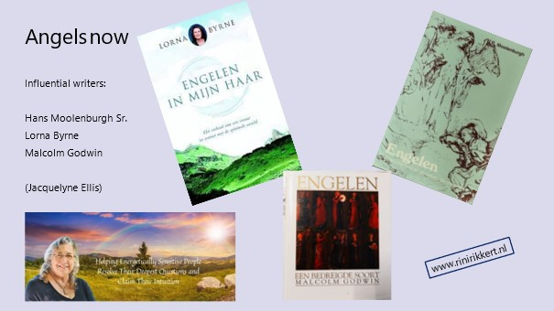

Fortunately, when we talk about angels in this day and age, there is a lot of good news to report. Since the beginning of the last century, attention has slowly but surely increased again, although the churches remained completely out of it. This interest had to do with all kinds of new developments, most of which fall under the title 'esotericism', and sometime from 1970 it is also called 'New Age'. Always a pity, such a label, because if you decide that this label does not suit you, then you do not have to take note of it…

People searched for new forms of spirituality, for new answers to questions about life and death, and in this environment the angels were also rediscovered. This time it were not the theologians, but often doctors who took the lead. People like Elisabeth Kübler-Ross and Pim van Lommel, who talked about 'near-death experiences', and the special fact that people who experienced something like this very often came up with the same stories. And then we come across those old ideas again, but now as new, unexpected experiences: the angel who accompanies you, the light, the love that engulfs you.

Kübler-Ross, who along with others investigated thousands of cases, writes:
"It is important to know that each person individually, from his first breath to the moment he dies, is surrounded by guides and guardian angels who await him and will assist him in the transition from earthly existence to life in the 'afterlife'."

Another way to get in touch with angels is through meditation. At least that's how I did it myself, and it takes a lot of practice. Not surprising, you also have that if you want to learn to play the piano. But it can also be different: in my work as a pastor, I have regularly met people who once had a onetime angelic experience. Most of the time, they didn't tell anyone: afraid that people thought they weren't mentally well, or just fantasizing...

Perhaps you have heard from the Dutch doctor – yes, another doctor – Hans Moolenburgh, who started his own research among his patients around 1960: he asked every visitor 'have you ever seen an angel?' To his surprise, 25% came up with a story. He wrote a book about it, which became a bestseller – and he wasn't the only one who wrote about experiences...

There is also a famous Irish woman, Lorna Byrne, who says she has seen angels and had contact with them since childhood. She writes books about it, and can be seen on youtube, I can definitely recommend you to meet her, she is a special woman. That includes the American Jacquelyne Ellis, not a book writer, but I did take some great courses with her. I also added my own website address here: there is a lot more angel information on it. Here in the Netherlands we also have the ex-pastor Hans Stolp, who wrote many books. He in turn is a pupil of the anthroposophist Rudolf Steiner.

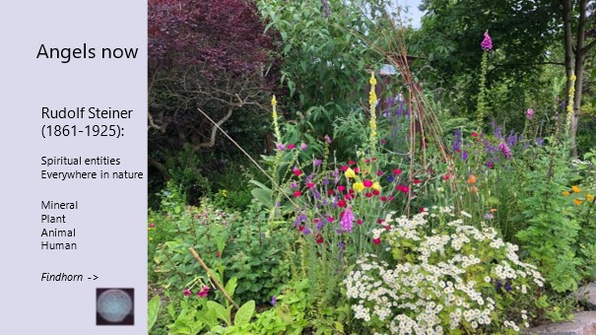

Until now, we have mainly talked about men and angels, but you still remember the people of antiquity, who sought the connection with the spirits and forces of nature and of the cosmos. More and more people rediscover this. For example, Rudolf Steiner added four orders to the nine that Dionysius had already recorded and called them the order of the spiritual entities in nature:
From high to low, these were the spiritual forces in man, the animal kingdom, the plant kingdom and the minerals.

In 1960, three people came to live on a bare piece of land in Scotland. One of them learned a method of getting in touch with the nature spirits, angels or devas, through something called 'automatic, or inspired writing'. The idea is that you do not make up the text yourself, but let that spirit speak through you. A bit like the bible writers and the prophets did. The Irish Dorothy (and a bit later one of the other two too) went to work, and received many messages, which also expressed great concern for the future of this earth.

They created a garden based on those assignments, which was extraordinary. The main goal was to show very concretely what unimaginable possibilities there were, if we learn to listen to and cooperate a little more with these creatures. It was given the name 'Findhorn', and still exists: there are now about 400 people living there who do their best to live in an alternative way.

Here is an example of such a message:
"You are children of the elements. You are made up of them and are part of them. The world and your bodies have been created over the course of long centuries so that you can express the joy of the Creator in all His manifestations. Man has a hard time because he feels separated. But how is that possible? Do you not know that the wind is a part of you, that the sun gives itself to you with every ray of sunshine and is part of you? Do you not know that you also come from water, that the water surrounds you all and that you could not live without breathing the air?

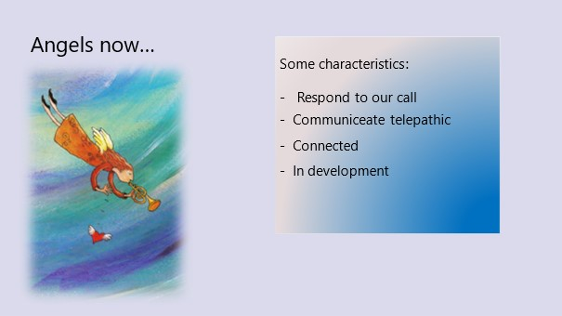

If we look at the characteristics as attributed to angels today, we see that the old ideas are often still there, and some developed further, but are still clearly recognizable. I name a few..
- To get their attention, all you have to do is ask them to do that. Your guardian angel is always with you.
- Angels can take different forms, but the 'denser' the form, the more effort it takes. Often they are seen as white spots, or swirling energy). On the previous picture you can see a white sphere, which I photographed myself without realizing it at the time, in the Lutheran chapel here in Dordrecht. Such a white sphere is also called an 'orb'. For me it was very special, especially because when meditating in that chapel before that time I already had the feeling that a guide or angel was present.
- They communicate telepathically (we have to convert that into language, with which messages always distort more or less). They can also make contact through our aura, or through all kinds of bodily sensations.
- God, angels, people, the earth, the cosmos: in the end it is one whole, everything is connected. What holds us together is called "love," and there is no place for power in it. Angels will always respect our own will.
- They are loving and serving, and lately the idea of development is also becoming more and more commonplace. Not only we, but also the angels and guides are in a learning process, and can grow further and further towards the Light.

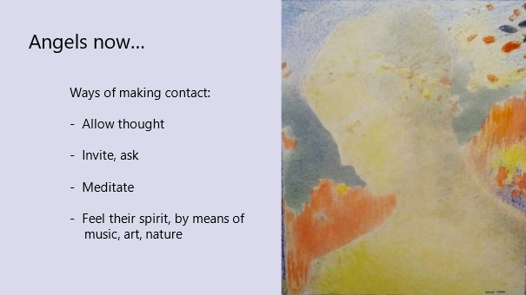

Unlike the stories in the Bible, today it seams easier to connect with angels and guides. ‘The time is now’, is often said. We are now so advanced that we no longer have to obey alone, but can also work with the angels. They want us to!

The first thing needed... allow the thought that it CAN be done. We tend to deny every experience immediately afterwards: ‘it must be a coincidence, or I must have made it up myself’, or you just find it scary. But if you are a bit inquisitive by nature, you can also decide to be open to it for a while, and ask your guardian angel for a sign. Don't tell them exactly what to do, just wait and pay attention. That's the simplest thing.
You can also decide to pray or meditate – and then not think or talk, but LISTEN as much as possible and ask your angel to help you. Finally, you can also come into contact with higher spheres through music, through art, through nature. It is mainly a matter of learning to tune in. And it's important – not only to start feeling better, but also for the light that you bring to the people around you, to the earth. It is SO needed….

THANK YOU

